Normal Distribution
(A special case of Probability-Distributions)

Review

1. Data types
1.1 Discrete : Gender, Marital Status, Education-Level, Satisfaction, etc.
1.2 Continuous : Heigth, Weigth, Length, etc.

2. Sample description
2.1 Central tendency (e.g., M, Mdn) summarize the center of a data distribution.
2.2 Dispersion (e.g., SD, IQR) describe the spread or variability of the data.

Today’s Topic

1. Probability VS. Empirical Probability
1.1 P ( A ) ∈ [ 0 , 1 ]
1.2 P ( x > a ) , P ( x < b ) , P ( a ≤ x < b )
Note : P ( x = a ) = 0 ( x ∼ Continuous )

2. Probability Dristribution

2.1 Discrete Data
Table 1
Probability Distribution of a Discrete Random Variable
X | ≤6 | 7 | 8 | 9 | 10
p | 0.15 | 0.30 | 0.35 | 0.15 | 0.05
Note. Data represent shooting scores.

2.2 Continuous Data
$$P(x<a)=\int_{−∞}^{a}{f(x)dx}$$
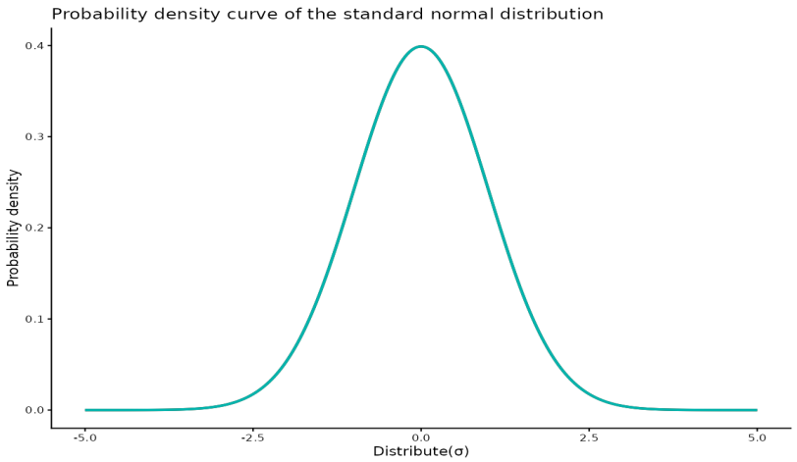

2.3 Property of probability distribution
2.3.1 $p_{i}≥ 0$
2.3.2 $\sum_{i=1}^{n}{p_{i}}=1$, x ∼ Discrete; $\int_{−∞}^{∞}{f(x)dx}=1$, x ∼ Continuous

3. Normal Distribution

3.1 Normal Distribution curve
$$f(x)=\frac{1}{σ\sqrt{2π}}e^{{−{(x−μ)}^{2}}/{2σ^{2}}},x\sim (μ,σ^{2})$$

3.2 Property of Normal Distribution curve
3.2.1 Unimodality: the curve reaches its maximum at the mean µ.
3.2.2 Symmetry: the curve is symmetric about the mean µ.
3.2.3 Two parameters: µ (location) and σ (scale, or spread). (Appendix : R ShinyApp)
3.2.4 Two inflection points: located at µ ±σ.
3.2.5 Domain: all real numbers, i.e., the curve extends from -∞ to +∞.

4. Standard Normal Distribution

4.1 Why Standard Normal ( e.g. $ )
4.1.1 Unified Reference: Transform any normal distribution to N(0,1)
4.1.2 Probability Calculation: One Z-table for all normal probabilities
4.1.3 Cross-Distribution Comparison: Z-scores enable comparison across different scales
4.1.4 Basis of Inferential Statistics: Critical values (CI) from Z-distribution
4.1.5 Outlier Detection: Objective rule: |Z| > 3 (3σ rule)

4.2 Transformation
$z=\frac{x−μ}{σ}$ ; $(z=\frac{x−\overline{x}}{s})$ (Appendix Derivation)

4.3 Standard Normal Distribution curve
$$f(z)=\frac{1}{\sqrt{2π}}e^{{−z^{2}}/2},z\sim (0,1)$$

4.4 Property of Standard Normal Distribution curve
4.4.1 Unimodality: the curve reaches its maximum at the mean 0.
4.4.2 Symmetry: the curve is symmetric about the mean 0 ( 0.5 + 0.5 ).
4.4.3 Two parameters: 0 (location) and 1 (scale, or spread). (Appendix : R ShinyApp)
4.4.4 Two inflection points: located at±1.
4.4.5 Domain: all real numbers, i.e., the curve extends from -∞ to +∞.

5. Z-Table

5.1 From z to p

5.2 From p to z
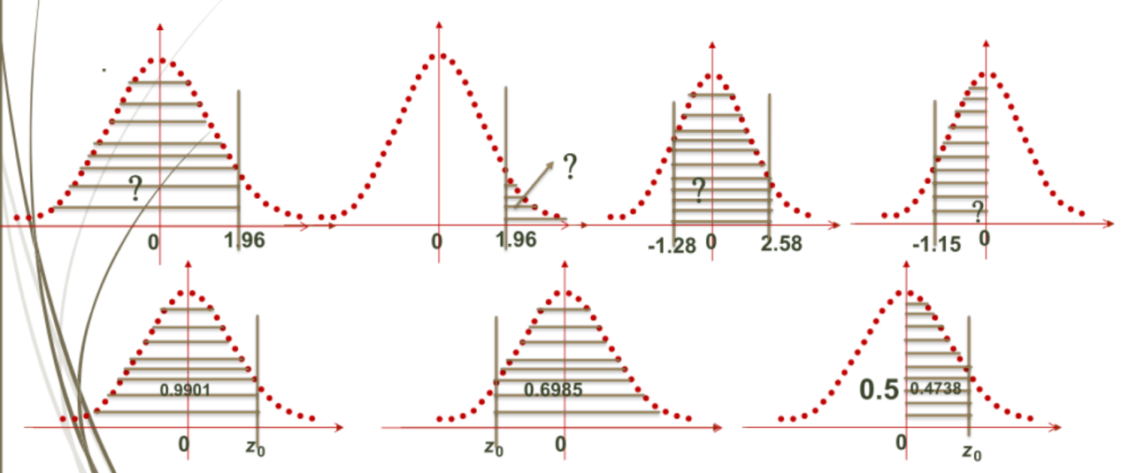

Appendix
1. 概念与理论类
1.1 简述正态分布的特征
1.2 简述标准正态分布与一般正态分布的区别与联系
1.3 名词解释：正态性检验
2. 应用与计算类
2.1 百分等级与标准分数计算
例题：某体院运动心理学测试中，学生焦虑量表得分呈正态分布，平均分为50，标准差为10。请问：
(1)某生得分为70分，其标准分数是多少？在该群体中大约超过百分之多少的人？
(2)如果要选拔得分在前10%的学生进行干预，分数线应划在多少分？
3. 易错点
3.1 “正态分布”：画钟形曲线并列出特征（对称、单峰、面积）
3.2 “正态性检验”：图示法（直方图、Q-Q图）与统计检验法（Shapiro-Wilk检验，适用于小样本；Kolmogorov-Smirnov检验，适用于大样本）
3.3 公式：Z分数计算

